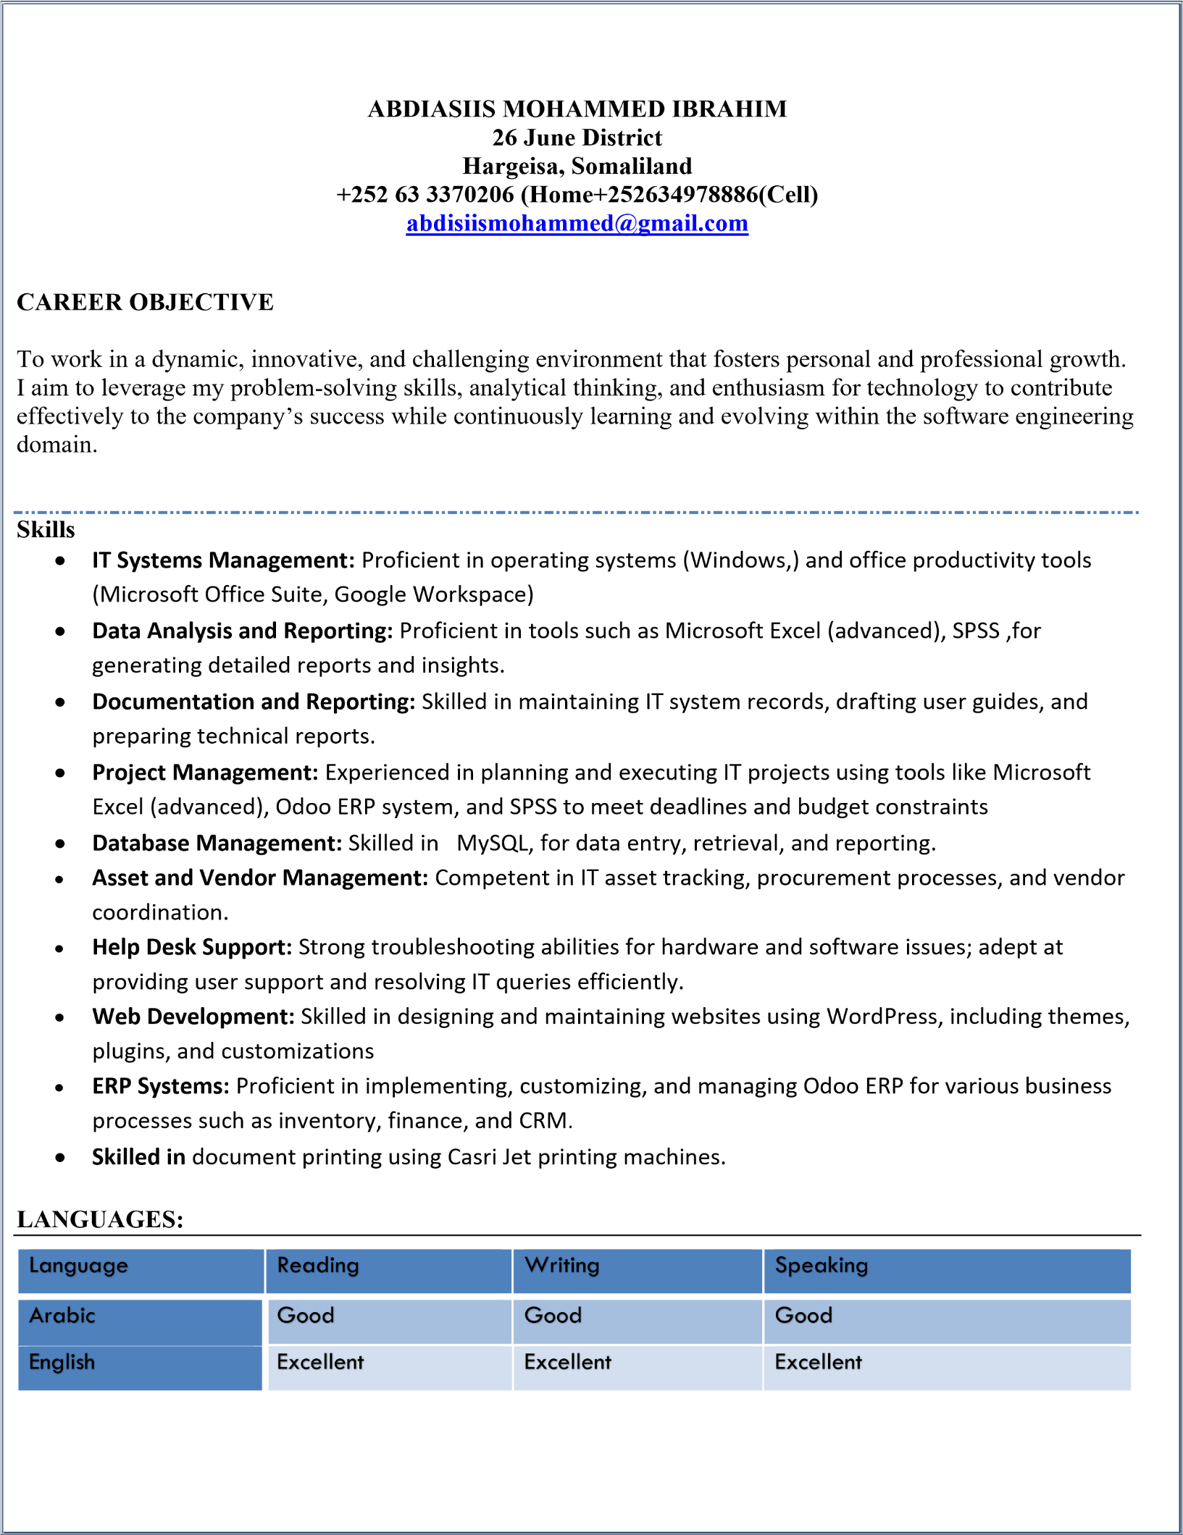
ACADEMIC BACKGROUND:
 |     Year Institution Attended | 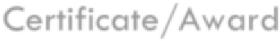  Certificate/Award
 |     2020-2023 Gollis University -Hargeisa | Bachelor Of Science On Software Engineering
 | 2018-2019 Sahal Software | Diploma For Computer Science
 | 12September2024 Admas University | Certificate of Odoo ERP system
 | August 17,2024 Hurbad Institute Of Technology | Certificate for graphic design and web development
 | 15 October 2024 Dedaal Academic Certificate for human management
2016 - 2020: sales representative, TAWAKAL electronics Hargeisa – Somaliland
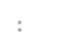

PROFESSIONAL EXPERIENCE
:

Job Purpose
interacts directly with customers throughout all phases of the sales process. They're responsible for identifying a customer's needs, pitching relevant products or services, and ensuring they have a positive experience from start to finish.
Main Tasks and Responsibilities

- Generating and pursuing potential clients.
- Negotiating contracts with clients.
- Assisting in setting pricing for services.
- Preparing regular reports.
- Presenting IT solutions to clients.
- Coordinating efforts with marketing strategies.
- Understanding and promoting company products.
- Processing client payments..
Visiting clients to assess needs and offer services. ▪ Managing client records.

2025: sales representative, Casri jet Hargeisa – Somaliland
Main Tasks and Responsibilities

- Presenting IT solutions and electronic products to clients.
- Processing client payments quickly and accurately.
- Printing and preparing all required documents for clients (invoices, contracts, service forms).
- Generating and following up on new client leads.
- Negotiating and finalizing sales agreements.
